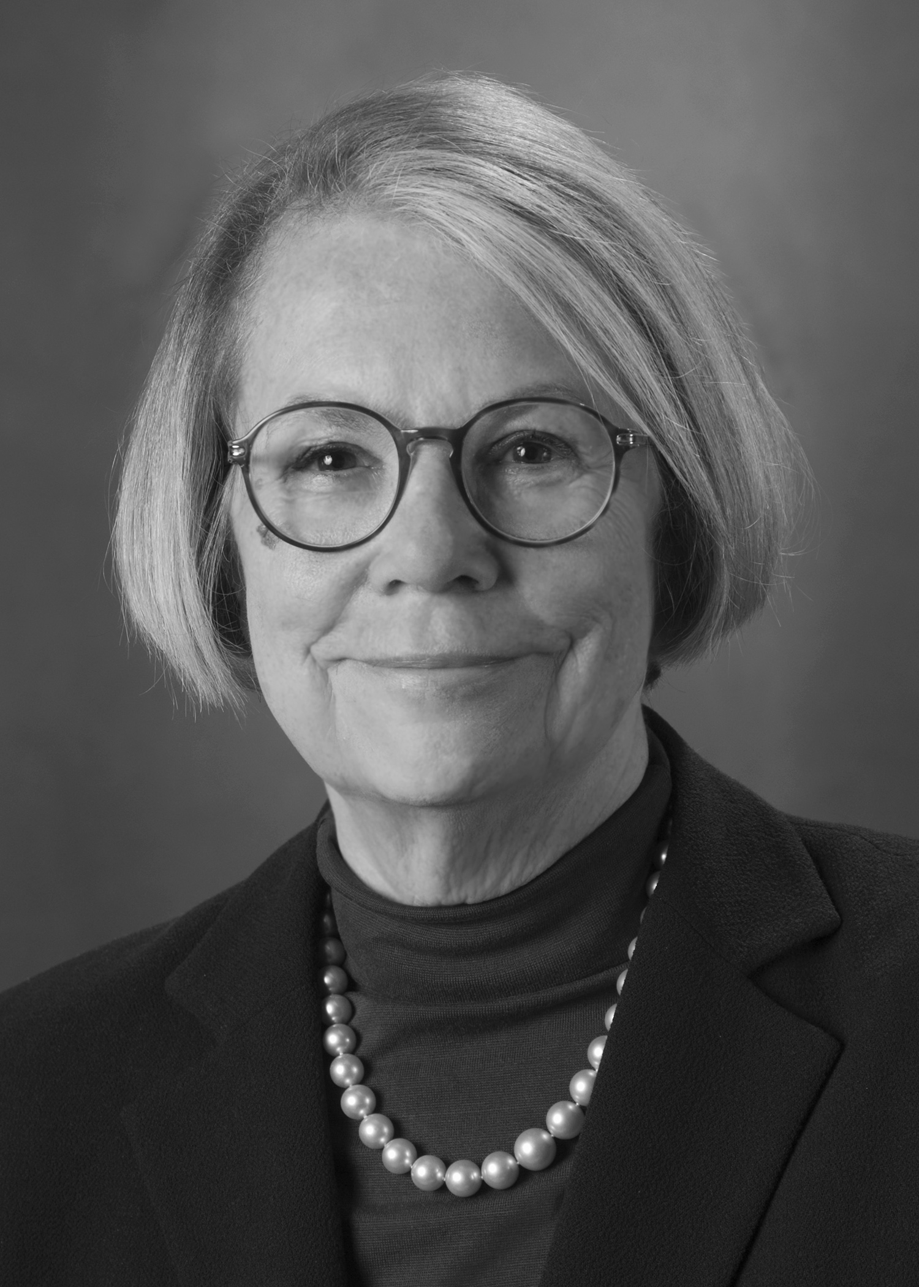
You are invited to an AIPAC MINNESOTA Community Briefing
Ann Lewis
Former Senior Advisor to Hillary Clinton and former Director of Communications and Counselor to President Bill Clinton

Taking a Stand and Making an Impact:
Why Our Votes Matter to the U.S.-Israel Relationship

Wednesday, September 2nd at 7:00 pm
Temple Israel Minneapolis
2324 Emerson Avenue South • Minneapolis
Hosted By:
Temple Israel Minneapolis
Susan and Gary Rappaport
Carol and David Rosenblatt

Dessert Reception (Dietary laws observed)
This event is free and open to the community.
Yes, you really can make an impact. The strength of the U.S.-Israel relationship is predicated on the relationships between pro-Israel activists and members of Congress. Pro-Israel advocacy has a direct impact on the future strength of U.S.-Israel relations, as well as the safety and security of the Jewish state. Without these essential efforts, many pro-Israel initiatives would not receive the overwhelming, bipartisan support they often get from both houses of Congress.

Please join us as Ann Lewis shares her experiences from the highest levels of the American political scene, discusses her unique approach to leadership and pro-Israel political activism, and explores how supporters of the U.S.-Israel relationship can get their message across more effectively.

Please RSVP by August 28th to AIPAC Minnesota Area Director Jeremy Wynes at (312) 253-8985 or jwynes@aipac.org.

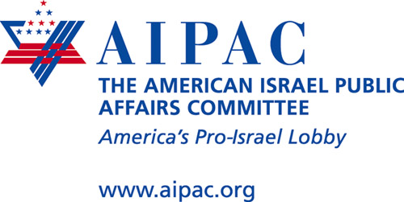

440 First Street NW
Suite 600
Washington, DC 20001

AIPAC Midwest Office
P.O. Box A3996
Chicago, IL 60690

Tel 312-253-8985
Fax 312-236-8530
www.aipac.org

Tel 312-253-8985
Fax 312-236-8530
www.aipac.org

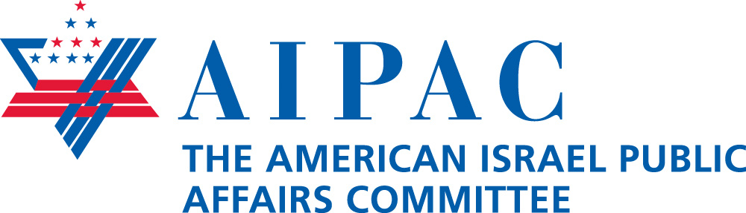
About Ann Lewis
Ann Lewis is a Senior Advisor to HillPAC, a leadership committee whose honorary chair is Hillary Rodham Clinton. She served in a similar capacity in the historic Hillary Clinton for President Campaign, where she oversaw outreach to women voters and to the Jewish community, and was a member of the Communications Team.
Lewis brought extensive political experience to the campaign, having served in the White House from 1997 –2000 as Director of Communications and then Counselor to President Bill Clinton. She was Director of Communications and Deputy Campaign Manager for the Clinton-Gore Re-Election Campaign in 1995- 1996, and Senior Advisor to the campaign of Hillary Rodham Clinton for U.S. Senate in 2000. As the National Chair of the DNC Women’s Vote Center from 2002- 2004 she led the Democratic Party’s major initiative to reach, engage, and mobilize women voters.
Ann Lewis was appointed by President Clinton as Co-Chair of the President's Commission on the Celebration of Women in American History and she was appointed by the President and Senator Daschle to the Women’s Progress Commission, established by Congress to report on women’s historical sites. She chaired the U.S. Government Working Group for the Women 2000: Beijing Plus Five Special Session of the General Assembly.
From 1994 to 1995, Lewis was the Vice President for Public Policy at the Planned Parenthood Federation of America. She has served as the National Director of Americans for Democratic Action, as the Political Director for the Democratic National Committee, and as Chief of Staff to then Congresswoman Barbara Mikulski.
A regular speaker on politics and current events in the United States and abroad, Lewis
co-chaired the 2006 American/Israel Women’s Dialogue sponsored by the American Jewish Congress and the University of Tel Aviv. She served on the Advisory Committee for the book Jews and American Politics, published in the fall of 2001.
In 2002, Lewis was nominated for an Emmy Award for her work on the script A Tribute to Heroes, broadcast on all networks following September 11, 2001.
About AIPAC
The American Israel Public Affairs Committee is the only American organization whose principal mission is to lobby the U.S. government about legislation that strengthens the relationship between the United States and Israel.

Every day, the professional staff and members of AIPAC are hard at work helping to educate members of Congress, candidates for public office, policymakers, media professionals and student leaders on college campuses about the importance of the U.S.-Israel friendship. Headquartered in Washington, D.C., the organization has 10 regional offices focused on bringing our message to legislators throughout the country.

Today, AIPAC is broadening and deepening the U.S.-Israel bond by working to secure vital aid for Israel to help ensure Israel remains strong and secure. AIPAC is working to promote strategic cooperation between the two nations, to develop sound U.S. anti-terrorist policies and to stop rogue nations such as Iran from acquiring a nuclear weapons capability.

AIPAC is registered as a domestic lobby and supported financially by private donations. The organization receives no financial assistance from Israel, any national organization or any foreign group. AIPAC is not a political action committee. It does not rate, endorse or contribute to candidates. Because it is a lobby, contributions to AIPAC are not tax deductible.

For more than 50 years, AIPAC has worked to make a difference. Because of your commitment to AIPAC, together we can continue to make a difference.

AIPAC Midwest Office
P.O. Box A3996
Chicago, IL 60690

